CSA0613 DESIGN ANALYSIS OF ALGORITHMS

CO1_ASSESSMENT TOOL 1_APPLICATION_BASED QUESTIONS

Q.25) Application: Fraud Detection System A fraud detection algorithm follows the recurrence T(n)=2T(n/2)+n2logn. Apply the Master Theorem to determine the time complexity. Compare f(n) with nlogb a and justify the correct case. Analyze performance for large transaction datasets. Interpret efficiency clearly. For assessment
Aim:
To analyze the recurrence relation T(n) = 2T(n/2) + n²logn using the Master Theorem and determine its time complexity for a fraud detection system.
Algorithm
Step 1: Start.
Step 2: Consider the recurrence relation:
T(n) = 2T(n/2) + n²logn )
Step 3: Set a = 2, b = 2 and f(n) = n²log(n).
Step 4: Compute n^(logb a) = n.
Step 5: Compare f(n) with n^(logb a).
Step 6: Since n²log(n) grows faster than n, apply Master Theorem Case 3.
Step 7: Therefore, Time Complexity = Theta( n²log(n)).
Step 8: Stop.

Python Program

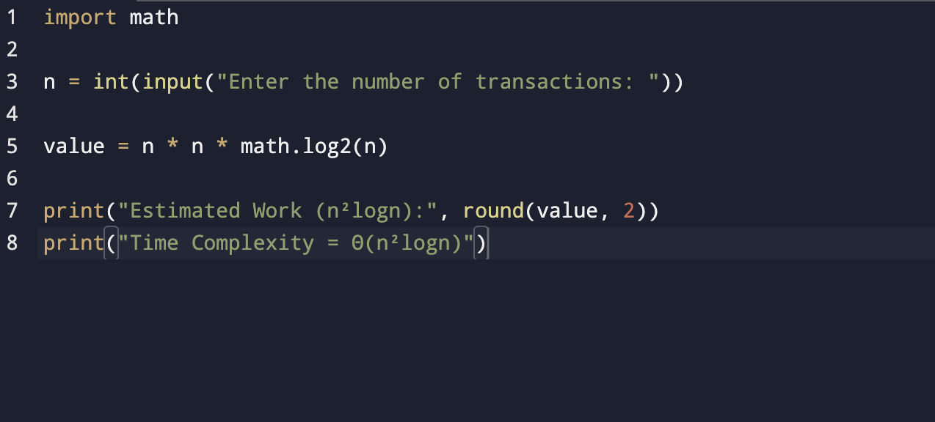
Output
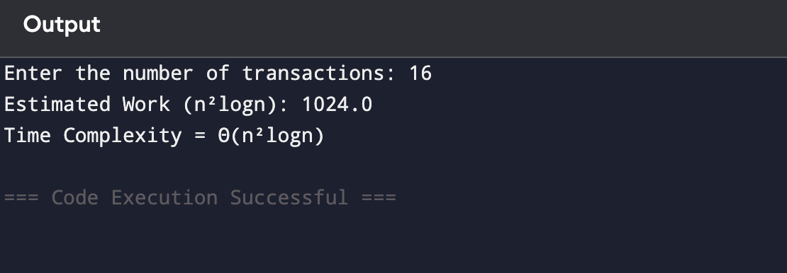
Time Complexity
Θ(n²logn )

Space Complexity
Θ(log n)

Result
The recurrence T(n)=T(n/2)+1 satisfies Master Theorem Case 2. Therefore, the time complexity is Θ(log n), making it efficient for real-time fraud detection.
Q34. Application: Online Banking Fraud Detection A fraud detection system analyzes transactions recursively:T(n) = T(n/2) + 1. Apply the Master Theorem and determine the time complexity. Identify the appropriate case and justify. Explain how this efficiency impacts real-time fraud detection performance

Aim
To analyze the recurrence relation T(n)=T(n/2)+1 using the Master Theorem and determine its time complexity for online banking fraud detection.
Algorithm
Step 1: Start.
Step 2: Consider the recurrence relation:
T(n) = T(n/2) + 1
Step 3: Set a = 1, b = 2 and f(n) = 1.
Step 4: Compute n^(logb a) = 1.
Step 5: Compare f(n) with n^(logb a).
Step 6: Apply Master Theorem Case 2.
Step 7: Therefore, Time Complexity = Theta(log n).
Step 8: Stop.

Python program
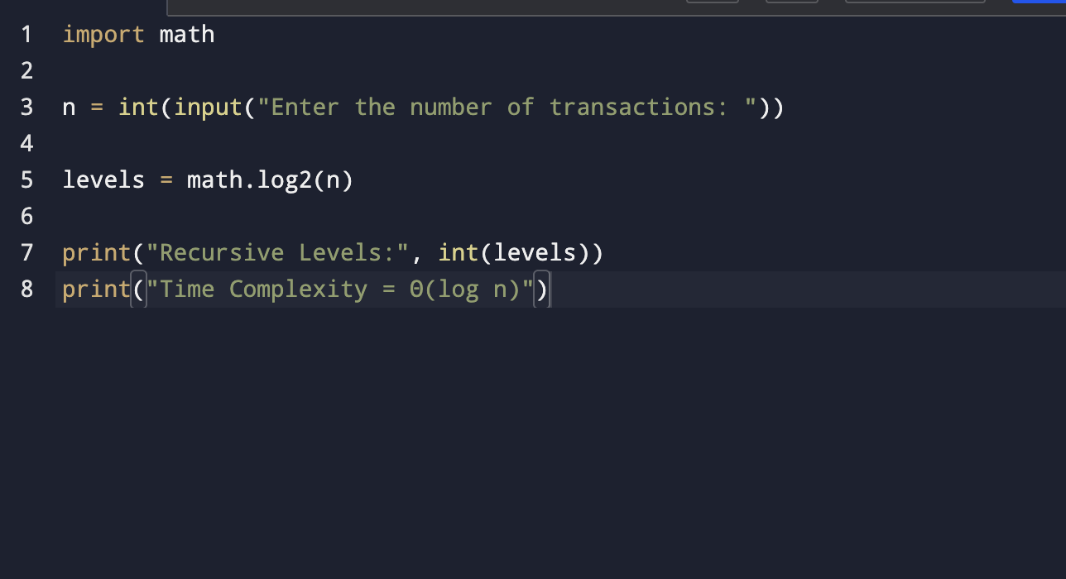
Output
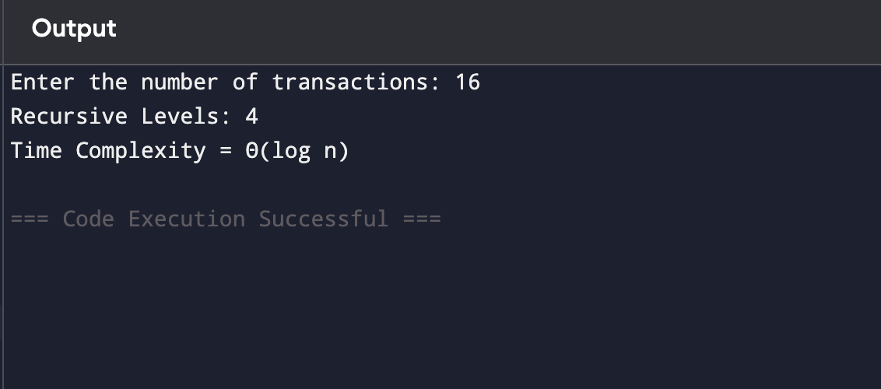

Time Complexity
Θ(log n)
Space Complexity
Θ(log n)

Result
The recurrence T(n)=T(n/2)+1 satisfies Master Theorem Case 2. Therefore, the time complexity is Θ(log n), making it efficient for real-time fraud detection.

